***READ ME FILE FOR ASSIGNMENT (Phase 1)***

Along with this read me file there are two java class files. After the connection establishment **Server** sends the file and **client** receives it.

To run follow the steps written bellow:

1. Place any file in any specific location which you want to share.
2. Open the class files of codes in netbeans.
3. Run the server class (As it should open the socket).
4. Run the client class.
5. As soon connection is established, server class (which is sending the file) will ask for address where the file is placed. Write complete path for example: if the file is in F drive it’s path will be **F://**
6. Give the correct name of the file, it’s extension without dot (.) and then the chunk size which for this assignment is 250.
7. Now on the Client side (which receives the file), enter the path or address where you want to save the received file along with the chunks. For example if you want to save in E drive it’s path would be **E://**
8. Then give the name with which you want to save file.
9. Write extension of received file without dot (.) and then the chunk size which is again 250 for this assignment.

This is all to run the code, if at the sender side it gives the exception of **file not found** this means that there is some mistake in the path given or name or extension of file.

After correct execution the code will show how many packets are sent and received at the both sides.

The received chunks and the complete merged file will be shown on the address you have given in the client (receiver ) side.

Snapshots is given to be viewed:

**Server (sender) side:**

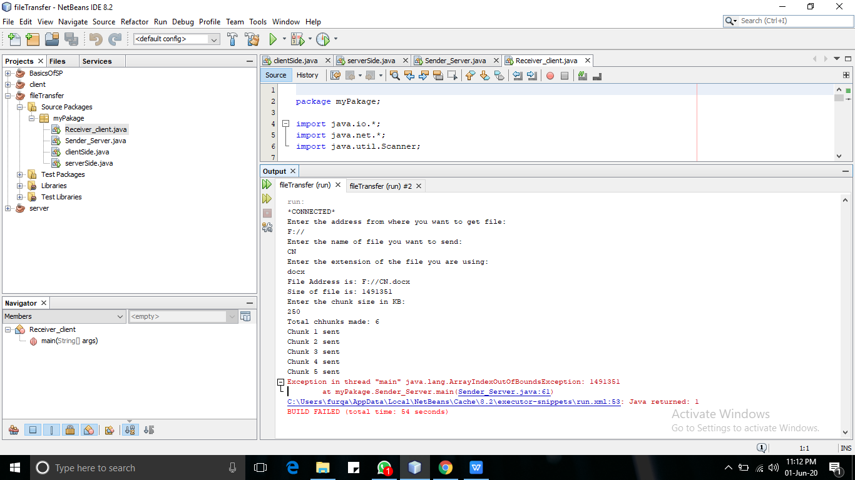

**Client (receiver) side:**

